Importing Ugrids into Pointwise V18.4

- Rename *.ugrid files to *.b8.ugrid
- Open Pointwise
- Select File -> Import -> Grid from the menu as shown below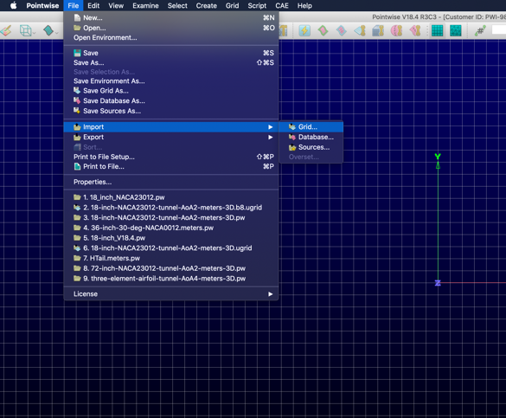
- Select NASA/FUN3D Grid Importer from dialog box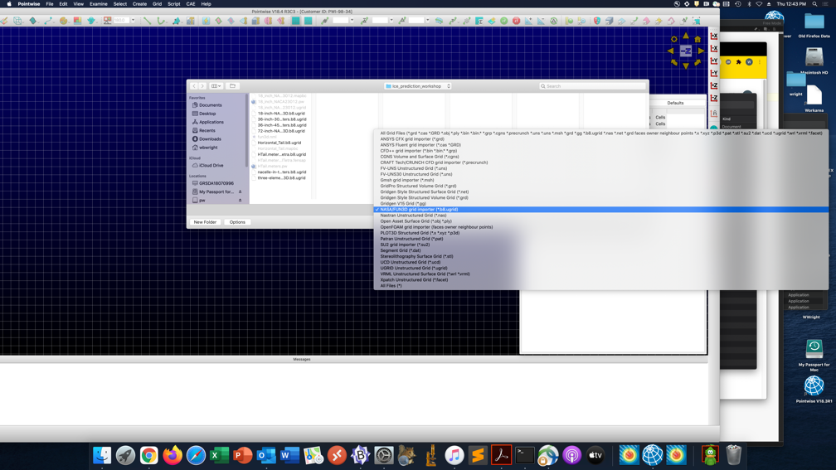
- Select OK from dialog box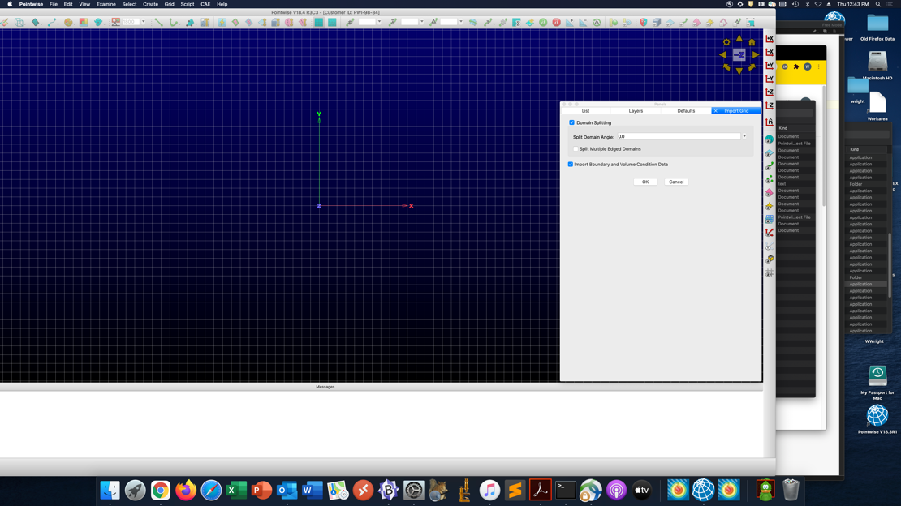
This import will take a few minutes to complete. The file can then be saved as a Pointwise file.

